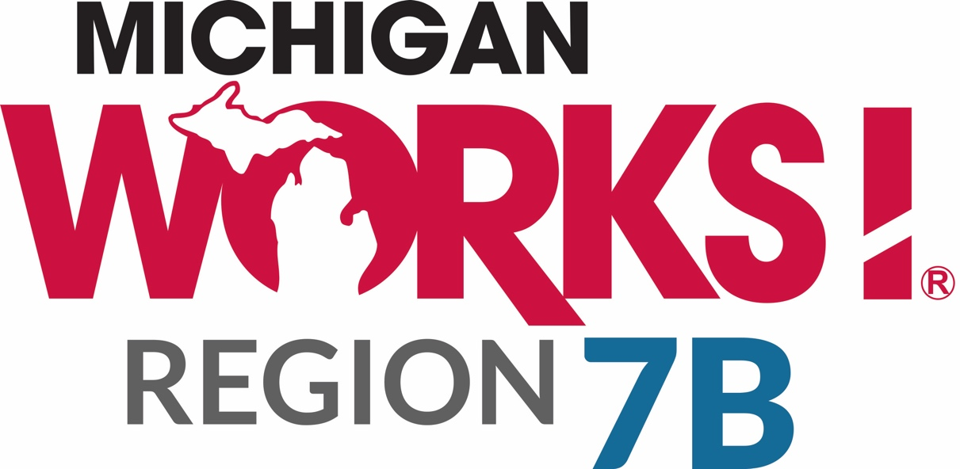

IT Support

Request For Proposal

August 2020

Michigan Works! Region 7B, an American Job Center, is an Equal Opportunity Employer/Program. Auxiliary aids and services are available upon request. Michigan Relay Center: 711 Voice and TDD. Supported by the State of Michigan.
Purpose

Michigan Works! Region 7B Consortium (MWA) is accepting proposals for support of its computers and network system. This includes support for hardware, software, installation, configuration, troubleshooting, networking administration, and network engineering for a Windows environment.

This Request for Proposal (RFP) does not commit the MWA to award a contract or pay any cost incurred in the preparation of a proposal. The MWA reserves the right to accept or reject any or all proposals or parts of proposals received as a result of this request. The MWA reserves the option to waive any informalities or minor irregularities in proposals. This MWA can cancel this RFP, in part or in its entirety, if it is in the best interest to do so. Verbal proposals will not be considered in making the award of any contract as a result of this RFP.

This MWA may require a proposer to enter into an agreement based on their proposal without further discussion or may require the proposer to enter negotiations. Proposers may be required to submit cost, technical or other revisions of their proposal that may result from such negotiation. This MWA reserves the right to request any additional data or discussion/presentation in support of the written proposal at any time, prior to the execution of a contract. The proposal may be referenced in the final contract except for those segments that were changed due to final negotiations. The contents of the final contract will take precedence over the proposal and/or the RFP document.

Schedule of Events

RFP Released: August 5, 2020
Deadline for submission of written questions: August 14, 2020
Answers to written questions posted on www.michworks4u.org: August 21, 2020
Proposals due: 4:00 p.m., August 28, 2020, to reg7b@michworks4u.org.

Services Period

The MWA expects to award services (and contracts if any) to one entity for the period of 10/1/20 – 6/30/21. The MWA may elect to exercise its option to extend services four additional years (i.e., 7/1/21 - 6/30/22; 7/1/22 - 6/30/23; 7/1/23 - 6/30/24; 7/1/24 – 6/30/25) based on the availability of funds, successful operation, and continued need.

Inquiries/Contact Information

All inquiries must be emailed to: reg7b@michworks4u.org using the subject heading “IT Support RFP Inquiry.” Responses to all questions will be posted on our website at www.michworks4u.org.

Evaluation of Proposals

Proposals will be evaluated based on a 100 point scale: up to 50 points for cost; up to 25 points for organizational structure including staffing levels, experience/expertise, longevity (staff and organizational), and credentials; up to 25 points for the degree to which services offered match MWA needs.

Submission of Proposal

All completed proposals are to be submitted in accordance with the terms, conditions, and procedures as stated herein. If duplicate proposals of the RFP are received from the bidder, only the last complete proposal submitted by the closing date and time indicated in this RFP may be reviewed and considered for funding. The MWA will not return any proposals to bidders for resubmission. All proposals submitted become the property of the MWA and are subject to the Freedom of Information Act.

For consideration, interested parties must, at a minimum, complete the Bidder’s Questionnaire, Certification of Independent Price/Cost Determination, Acceptance of Conditions of RFP, Conflict of Interest, and the Certification Regarding Debarment and Suspension forms. Bidders may include up to five additional pages of information.

Parties interested in providing the services as outlined in this RFP must submit a proposal by 4:00 p.m. EST on August 28, 2020. Proposals submitted via email to reg7b@michworks4u.org or hard copies delivered to 402 N. First St., Harrison, MI 48625 will be accepted.

Proposal Content

The proposal must enable this MWA to understand completely how the bidder intends to provide the services. From the information provided, the MWA will determine the extent to which the proposal is consistent with the requirements of this RFP. It is understood and agreed that the bidder claims no proprietary rights to the ideas and written materials contained in or attached to the proposal submitted in response to this RFP. All proposals submitted become the property of this MWA.

Proposals developed with the assistance of organizations or individuals outside the bidder’s own organization (including paid consultants) are to be identified. No contingent fees for such assistance will be paid under any contract resulting from this RFP.

All proposals submitted by a consortium of companies or agencies must have a certification that each company and/or agency of the consortium can meet the requirements of the RFP.

The proposals warrants that the charges quoted are not in excess of those which would be charged any other individual for the same services performed by the bidder. Any and all cost in excess of actual cost of services must be identified.

The bidder guarantees that, in connection with this proposal, the prices and or costs data have been arrived at independently, without consultation, communication or agreement for the purpose of restricting competition. This does not preclude or impede the formation of a consortium of companies and/or agencies.

Proposals that do not contain completed information as required will be downgraded in the evaluation process and/or may be considered non-responsive.

Network Description

The MWA utilizes a six county fiber optic Wide Area Network. Each office consists of a Local Area Network (LAN) over Ethernet. Staff and customer workstations are Windows 10. The MWA is operating a virtualization platform using VMware Essentials Plus Version with vCenter.

Service Locations

Bidders must have the ability to promptly provide on-site support at all of the following Michigan Works! Service Center locations: Harrison, Gladwin, Prudenville, Standish, East Tawas, and West Branch. Support is also required for a satellite office in Saginaw.

BIDDER QUESTIONNAIRE

Name of Firm:

Address:

Contact Person and Title:

Phone:

- Are you a corporation in the State of Michigan?
  - If yes, what year incorporated?
- Identify the owners?
- Where is your company headquartered?
- Please indicate your staffing levels:
Staffing Category | Number of Individuals
Total staff
Sales
Technical
Admin
Contractors
Other (explain)

- List your technical staff individually along with:
  - Longevity with your company
  - Certification levels
  - Longevity at the certification level
- Which of the above employees are available to work on installation and troubleshooting?
- Do you have experience with network copy machines?
  - If yes, elaborate.
  - Identify your experience and qualifications/certifications with network printers?

- How many Microsoft networks do you support?
  - Describe the largest network you support (in terms of users, workstations and printers) and how long you have supported it?
- How many and what type of networks (Linux, and Microsoft) have you installed?
- Indicate your experience/qualifications/certifications with the following products:
  - Sophos
  - Cisco routers
  - VMware Essentials Plus and vCenter
  - Novell SLES Linux
  - HP network equipment
- Are you a certified HP and/or Dell service provider?
- Will support be provided out of your headquarters?
  - If no, where is local support provided?
- Are you able to provide on-site support in Harrison, Gladwin, East Tawas, Prudenville, Saginaw, Standish and West Branch?
- Do you provide a toll free number for support?
- How are your service calls prioritized?
  - Criteria used?
- Do you offer any pre-designed maintenance/support contracts?
  - If yes, please elaborate and identify the cost?
- Do you offer customized maintenance/support contracts?
  - If yes, please elaborate and identify the cost?
- Is the monitoring of software patches covered under a contract?
- Will you be subcontracting any of the work you are proposing to provide?
- How are support hours tracked, verified and billed?
- What hours are your standard support available?
- Is there emergency, night, weekend, and holiday service available?
- Is standard 24 X 7 coverage available?
  - Variations?
- How is support following installation handled, such as free for 60 days, then maintenance contract takes effect?
- Do you have full time product support positions?
- How many positions do you have in your product support department?
- Are the product support positions filled by certified technical personnel (such as software engineers)?
  - If no, explain.
- Does the on-site response time include travel time from your office to the site?
- What is your average response time for a service call?
  - Phone Response
  - On-Site Response
- What is the customer’s recourse if you do not respond within this time limit?
- Which remote access software do you use for support purposes?
- Do you perform any wiring services (e.g., running category cable, making patch cables, etc.)? If yes, provide pricing information.
- Do you perform any of the following services:
  - Physically transporting equipment
  - Unpacking
  - Setting up
  - Verification that equipment is operating correctly?
- Do you provide warranty service for any of the following?
  - Servers
  - Workstations
  - Printers
  - Other Components
- Do you provide any type of voice services such as VOIP?
- List following rates:
  - Standard Travel Rate?
  - Rate During warranty period?
  - After warranty expires?
  - With a support contract?
  - Without a support contract?
  - With hardware maintenance?
  - Without hardware maintenance?
- Do you charge for travel time?
  - Do you charge service hours for travel or simply mileage?
- How long are the rates identified in this proposal valid?
- What is your hourly rate for Microsoft, and Linux Engineers?
  - Identify if there are different hourly rates. For example, is there a contract rate and a non-contract rate; or if a certain number of hours must be purchased to obtain a certain rate?
- If you are not our current provider, how will you familiarize yourself with our network?
  - Indicate how long you think this will take and any costs associated with this?
- Do you have other relevant experience?
- Please provide three current customer references with contact information.
CERTIFICATION OF INDEPENDENT PRICE/COST DETERMINATION

Note: This certification must be signed and returned in the proposal package.

A. By submission of this proposal, each offeror certifies, and in the case of a joint proposal each party thereto certifies as to its own organization, that in connection with this procurement action:

1. The prices in this proposal have been arrived at independently, without consultation, communication, or agreement, for the purpose of restricting completion, as to any matter relating to such prices with any other offeror or with any competitor;
2. Unless otherwise required by law, the prices which have been quoted in this proposal have not knowingly been disclosed by the offeror prior to award, directly or indirectly to any other offeror or to any competitor; and
3. No attempt has been made or will be made by the offeror to include any other person or firm to submit or not to submit a proposal for the purpose of restricting competition.

B. Each person signing this proposal certifies that:

1. S/he is the person in the offeror's organization responsible for the decision as to the prices being offered herein and that s/he has not participated, and will not participate, in any action contrary to A.1 through A.3 above; or
2. S/he is not the person in the offeror's organization responsible within that organization for the decision as to the prices being offered herein but s/he has been authorized for such decision in certifying that such persons have not participated, and shall not participate, in any action contrary to A.1 through A.3 above, and as their agent does hereby so certify; and s/he has not participated, and shall not participate, in any action contrary to A.1 through A.3 above.

C. This certification is not applicable to a foreign offeror submitted proposal for a contract, which requires performance or delivery outside the United States, its possessions, or Puerto Rico.

D. A proposal shall not be considered for award where A.1, A.3, or B. above has been deleted or modified. Where A.2 above has been deleted or modified, the proposal shall not be considered for award unless the offeror furnishes with the proposal a signed statement which sets forth in detail the circumstances of the disclosure and the head of the agency, or his/her designee, determines that such disclosure was not made for the purpose of restricting completion.

Authorized Signature______________________________________Date_________________

Typed/Printed Name of Authorized Signature_______________________________
CONFLICT OF INTEREST STATEMENT

By my signature, I certify to the following statements:

No employee of Michigan Works! Agency or member of the Workforce Development Board, or Board of Directors has any direct interest, financial or otherwise, in this organization.

[ ] Correct [ ] Incorrect

No officer of any government, government agency has any direct interest, financial or otherwise, in this organization.

[ ] Correct [ ] Incorrect

*If incorrect was marked, you must list the person or persons which have an interest, financial or otherwise with the organization. Their relationship with the organization must also be listed.

Name

Relationship

Organization’s Name

Date

Signature
ACCEPTANCE OF CONDITION OF RFP

Name of agency submitting proposal

Does hereby accept all the term and conditions of the Request for Proposal and the Subsequent Format enclosed therein. The Proposer also certifies that the information in the Response Package is correct to the best of his/her knowledge and belief, that the fling of the Response Package has been fully authorized, and that proof of this authorization is attached. All communications relative to the Proposal shall be transmitted to the name in this certification unless written assignment is made by the person named below.

The following signatory is authorized to sign as agent for the above-mentioned agency.

Signature

Typed/Printed Name and Title

Date
CERTIFICATION REGARDING
DEBARMENT AND SUSPENSION

This certification is required by the regulations implementing Executive Order 12549 and 12689, Debarment and Suspension, 29 CFR Part 98, Section 98.510, Participants’ Responsibilities. The regulations were published as Part VII of the May 26, 1988, Federal Register (pages 19160 – 19211).

1. The prospective recipient (i.e., Contractor) of Federal assistance funds certifies that neither it nor its principals are presently debarred, suspended, proposed for debarment, declared ineligible, or voluntarily excluded from participation in this transaction by any Federal department or agency.

2. Where the prospective recipient (i.e., Contractor) of Federal assistance funds is unable to certify to any of the statements in this certification, such prospective participant shall attach an explanation to this Contract.

_____________________________________________________________________
Name and Title of Authorized Representative

__________________________________ __________________________
Signature Date

