Four-Year WIOA Regional Plan

September 1, 2020 – June 30, 2024

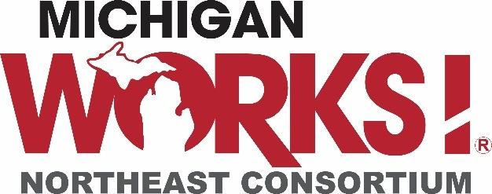
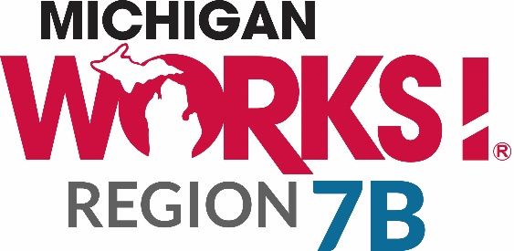

Michigan Works! Northeast Consortium and Michigan Works! Region 7B are equal opportunity employer/programs. Proud partners of the American Job Center Network. Auxiliary aids and services are available upon request. Supported by the State of Michigan. Funded with federal funds; details available at www.nemcworks.org/mw.asp. and www.michworks4u.org TTY#711

During the process of developing this regional plan, stakeholders were asked, “what is your biggest and brightest hope for the future of the region?” Answers included the following:
- “Create a buzz about the benefits of this region”
- “It’s the place to be!”
- “We offer a great life for families”
- “It’s time to shine”
- “Happy faces and money in pockets”
While individual answers varied, they all had one theme in common: Potential.
WIOA Region 3 is a geographically large area, with a small population size; it suffers from low wages, higher than average poverty, and many challenges that are inherent to rural areas. However, the people who work, live, and play in Northeast Michigan are proud of their communities. They are focused on the positive, and are committed to working together for the benefit of everyone in the region.
This vision of great Potential for the region aligns well with the state of Michigan’s Strategic Vision, as expressed in the Unified State Plan:
“Make Michigan a place where all PEOPLE, BUSINESSES, AND COMMUNITIES have the educational and economic means to reach their full potential.”
Northeast Michigan’s goals, strategies, and collaborative activities for the coming four years will seek this same vision for WIOA Region 3. In order to achieve this vision, the region commits to the following:
- Leverage the region’s strength of Partnerships and Collaboration to improve efficiency, increase resources, and expand services;
- Catalyze Business Engagement activities to build career pathways, increase work-based learning opportunities and credential attainment, and increase employee retention;
- Use Sector Partnerships and other business collaborations to address systemic barriers to employment, including lack of adequate transportation;
- Work with regional entities to address insufficient broadband infrastructure.

The region’s faith in its future potential can be seen in the above commitments and in the many strategies presented in this regional plan. Despite discouraging statistics, the region seeks to leverage its many strengths, and stakeholders will work diligently to enact the plan as presented here.

Table of Contents
Executive Summary 3
Planning Process 5
Regional Labor Market Data and Economic Conditions 6
Regional Service Strategies 24
Sector Initiatives 27
Administrative Cost Arrangements 28
Coordination of Transportation and other Supportive Services 29
Coordination with Economic Development 32
Performance Negotiation 34

Table of Figures
Figure 1: Occupation Gaps 9
Figure 2: Change in Population by Age Range 12
Figure 3: Projected Change in Population by County, 2020 – 2030 12
Figure 4: Unemployment Rate Trends, 2008 – 2019 14
Figure 5: Educational Attainment, 2012 – 2018 14
Figure 6: Skill Gaps 15
Figure 7: Individuals with Disabilities, 2013 – 2018 16
Figure 8: Change in Public Assistance, 2013 – 2018 16
Figure 9: Poverty Levels and ALICE Households, 2010 – 2017 17
Figure 10: Free Wifi Hotspot Availability 22

Table of Tables
Table 1: Industry Employment and Wages (2019) – WIOA Region 3 6
Table 2: Vulnerability to Job Loss due to COVID-19 (2020) – WIOA Region 3 7
Table 3: Industry Demand, 1-year Projection (2019-2020) – WIOA Region 3 7
Table 4: POPULATION TRENDS, 2013–2019 11
Table 5: Labor Force and Unemployment Rate (Dec. 2019) – WIOA Region 3 13
Table 6: Top 20 Awards by Program (2017-2018) – WIOA Region 3 20

Executive Summary
The workforce development system in Northeast Michigan is a network of services, programs, and resources whose primary purpose is to develop a skilled workforce to match employer needs. This network consists of many providers, all of whom are committed to working together for the good of the region.
The Workforce Innovation & Opportunity Act (WIOA) is the primary workforce legislation for the United States. This legislation supports employer relationships that drive workforce preparation, implemented through robust partnerships. It emphasizes regional collaboration and planning, and therefore requires that a comprehensive plan be developed across regions, incorporating input from all stakeholders. This WIOA Regional Plan presents the goals, strategies, and activities of numerous partners in WIOA Planning Region 3. The region covers 14 counties: Alcona, Alpena, Arenac, Cheboygan, Clare, Crawford, Gladwin, Iosco, Montmorency, Ogemaw, Oscoda, Otsego, Presque Isle, and Roscommon.
The process for creating this plan involved representation from all WIOA partners. The two Michigan Works! Agencies in the region – Michigan Works! Northeast Consortium and Michigan Works! Region 7B – convened a strategy session with these partners. The group reviewed data, assessed the workforce system, developed goals, and brainstormed strategies for the coming four years. The process also included a survey, individual interviews with partners, regular meetings of leadership, review and approval by both workforce development boards, and a 30-day public comment period.

Regional Labor Market Data and Economic Conditions
The 14-county region covers a geographically large expanse of 7,865 square miles, which is equivalent to the entire state of Massachusetts. Largely rural, it is sparsely populated, with less than 275,000 people. This presents several challenges for economic prosperity, which are reflected in the data presented in this plan.
Labor market data for the region shows higher than statewide averages for numerous data points, including unemployment rates, poverty levels, and use of public assistance. This is largely due to difficulties accessing resources, such as public transportation and childcare, which are not widely available, as well as fewer job opportunities that provide a family-supporting wage. The job opportunities that are highest in demand are service occupations that may be seasonal and typically pay lower rates. However, many other industries are growing and offer skilled positions; these include Manufacturing, Healthcare, Construction, and Transportation. Many of these positions require a high school diploma and some postsecondary training, such as a certificate and in some cases an Associate’s Degree. High quality training programs are available for all demand occupations, but they are not readily accessible in all parts of the region.

The Workforce System
The workforce system in the region is dedicated to collaborative approaches that overcome many of the challenges reflected in labor market data; together the partners are passionate about increasing economic prosperity for the many communities they serve. The system’s strengths include partnerships that leverage resources, engagement with local employers, and an effective education system. The system’s weaknesses (or challenges) include limited critical infrastructure, including lack of public transportation, available and affordable childcare, and broadband internet access. The system’s capacity is constrained by many of these limitations, as well as insufficient funding to address these many needs.

Regional Service Strategies
In order to leverage strengths and mitigate challenges, the workforce system has collaboratively developed several goals and strategies. These include, but are not limited to:
- Use employer-led collaboratives to address systemic barriers to long-term, sustainable employment
- Leverage the strong collaborative spirit in the region to increase resources, improve services, and ensure efficiency
- Increase transportation capacity for the local workforce
- Increase awareness of local career opportunities among youth and families
- Enhance talent attraction and retention through coordinated regional marketing and advocacy
The system is well-positioned to implement these strategies, due to the significant levels of collaboration that are already the norm. Several activities are already underway that align with the above, including business resource networks, industry sector-based approaches, career awareness events, supportive services, and support for economic development projects.

Sector Initiatives
WIOA emphasizes working collaboratively with employers within an industry sector, in order to encourage cooperation and respond comprehensively to shared workforce needs. The workforce system in the region implements sector approaches through career awareness events, career pathways, and by working with existing industry associations.

Coordination with Transportation and Supportive Services
The network of resources that comprise the workforce system includes community resources that help job seekers to overcome barriers. Therefore, the system works collaboratively with providers of these resources to better understand their programs and ensure robust partnership. Examples of coordination include membership in human services collaboratives and both Regional Prosperity Initiatives that cover the region. The system commits to enhancing its relationships with transportation providers, such as public transit, and finding innovative ways to expand transportation capacity for the local workforce.

Coordination with Economic Development
The system works collaboratively with all economic development entities in the region, including the statewide Michigan Economic Development Corporation. Activities include retention visits, collaboration on attraction and expansion packages, and ongoing communication. Most workforce practitioners who work with employers are certified in the Business Solutions Professional approach. This provides a common framework for determining employer needs and collaboratively finding customized solutions.

The WIOA Regional Plan for the 14-county region reflects the workforce system’s existing activities, expanded strategies, and new approaches for the coming 4 years. Developed through a collaborative process, it is a blueprint for working together to achieve prosperity for the workforce, businesses, and communities.

Planning Process
1. A description of the planning process undertaken to produce the regional plan, including a description of how all local areas were afforded the opportunity to participate in the regional planning process.
The workforce development system in Region 3 conducted a comprehensive process to produce this plan. The process included numerous opportunities for all stakeholders to participate and share their perspective on partnerships and collaboration, as well as improving and expanding services for both job seekers and employers.
A facilitator was engaged to conduct a day-long “Strategy Session” for the purpose of reviewing data, analyzing strengths and weaknesses across the region, and brainstorming opportunities. Attendees at this Strategy Session included the following:
- Leadership from both Michigan Works! Agencies
- Board members – both local elected officials and workforce development boards – representing each local area
- Representatives from the following WIOA Core and Required partners:
  - Veterans Services
  - Migrant and Seasonal Farmworker Services
  - Michigan Industry Cluster Alliance
  - Adult education
  - Michigan Rehabilitation Services
  - Economic development
  - Department of Health and Human Services
  - Postsecondary Carl Perkins programs
  - Community Action Agency
  - Unemployment Insurance Agency
  - Local employers
The Strategy Session resulted in a long list of opportunities that the region could pursue to improve and expand services, develop partnerships, and collaboratively assist communities with overcoming barriers to economic growth. This input was used to formulate potential strategies for regional workforce development activities.
A survey was developed and sent back to the group, in order to confirm and validate that the strategies accurately expressed their wishes. It also allowed them to prioritize and assess feasibility for each potential strategy. The results were used to shape the regional strategies seen throughout this plan.
In addition to the Strategy Session and survey, leadership from WIOA Core Partners met to discuss the regional plan and ensure that it truly represents the voice of the region. In addition to board representatives in the strategy session, the plan was presented to both workforce development boards and local elected officials boards. Also, public comment was sought for a 30-day period from June 22, 2020 to July 21, 2020.

Regional Labor Market Data and Economic Conditions
2. An updated and thorough analysis of regional labor market data and economic conditions for the WIOA Planning Region.
- This shall include an analysis of existing and emerging in-demand industry sectors and occupations, and the employment needs of employers in those existing and emerging in-demand industry sectors and occupations.

In-Demand Industry Sectors
All industries in the 14-county region are displayed below in Table 1, along with current (2019) employment numbers, percent of total employment, and average annual wage. The industries with the highest volume and proportion of jobs are high-demand, although not all of those jobs offer family-sustaining wages.
Table 1: Industry Employment and Wages (2019) – WIOA Region 3
NAICS | Industry | Employed | % of Total | Avg Ann Wages
44 | Retail Trade | 13,566 | 16.3% | $28,090
62 | Health Care and Social Assistance | 11,869 | 14.3% | $40,652
31 | Manufacturing | 9,433 | 11.4% | $48,848
72 | Accommodation and Food Services | 8,674 | 10.4% | $16,819
23 | Construction | 6,009 | 7.2% | $43,393
92 | Public Administration | 5,407 | 6.5% | $38,907
61 | Educational Services | 4,988 | 6.0% | $38,675
81 | Other Services (except Public Administration) | 4,081 | 4.9% | $23,462
48 | Transportation and Warehousing | 3,216 | 3.9% | $60,747
11 | Agriculture, Forestry, Fishing and Hunting | 2,664 | 3.2% | $22,275
56 | Administrative and Support and Waste Management and Remediation Services | 2,479 | 3.0% | $27,996
54 | Professional, Scientific, and Technical Services | 2,121 | 2.6% | $51,069
52 | Finance and Insurance | 2,098 | 2.5% | $55,585
42 | Wholesale Trade | 1,937 | 2.3% | $50,014
71 | Arts, Entertainment, and Recreation | 1,401 | 1.7% | $21,195
53 | Real Estate and Rental and Leasing | 970 | 1.2% | $35,138
51 | Information | 859 | 1.0% | $32,656
21 | Mining, Quarrying, and Oil and Gas Extraction | 667 | 0.8% | $67,001
22 | Utilities | 307 | 0.4% | $81,855
99 | Unclassified | 162 | 0.2% | $27,935
55 | Management of Companies and Enterprises | 120 | 0.1% | $75,845
 | Total - All Industries | 83,030 |  | $37,438
Source: JobsEQ®, Data as of 2019Q3
Table 2: Vulnerability to Job Loss due to COVID-19 (2020) – WIOA Region 3
County | Vulnerability Index
Cheboygan County | 134.64
Oscoda County | 126.18
Iosco County | 118.39
Otsego County | 115.7
Ogemaw County | 106.5
Clare County | 100.79
Crawford County | 100.35
Arenac County | 98.73
Chippewa County | 97.94
Alpena County | 93.84
Gladwin County | 89.5
Alcona County | 89.44
Presque Isle County | 87.18
Montmorency County | 79.33
Source: Chmurra, 2020
With Retail Trade and Accommodation and Food Services residing in the top 5 of demand industries, it is clear that the economy of the region is heavily reliant on tourism. These two industries make up 27.8% of the total jobs.
Expanding job opportunities in other industries would diversify the overall economy, making the region less susceptible to shifts in tourism-related activities. This is especially true during the era of COVID-19. With restricted travel, fear of visiting restaurants and hotels, and cancellation of festivals, the region’s economic base is at great risk.
A recent study by Chmurra indicates that half of the region’s counties are predicted to fall above the average job loss in the United States (indicated by a vulnerability index score of 100) due to COVID-19. Table 2 (right) shows the vulnerability index score for each county in the region. It is important to note that a score of 100 is the anticipated average job loss across the US, so a score below 100 still indicates some job loss.
In addition to the anticipated job loss due to COVID-19, several industries are projected to decline in the short term. Table 3 below shows the same list of industries as Table 1, with a projected 1-year demand. Unfortunately, most industries are projected to decline in this period, including those that are not reliant on tourism.
Table 3: Industry Demand, 1-year Projection (2019-2020) – WIOA Region 3
NAICS | Industry | Total Demand | Exits | Transfers | Growth | Ann % Growth
44 | Retail Trade | 1,662 | 797 | 1,007 | -142 | -1.0%
62 | Health Care and Social Assistance | 1,162 | 550 | 568 | 44 | 0.4%
31 | Manufacturing | 855 | 361 | 617 | -123 | -1.3%
72 | Accommodation and Food Services | 1,402 | 620 | 781 | 1 | 0.0%
23 | Construction | 594 | 211 | 378 | 5 | 0.1%
92 | Public Administration | 454 | 209 | 285 | -40 | -0.7%
61 | Educational Services | 414 | 221 | 238 | -45 | -0.9%
81 | Other Services (except Public Administration) | 432 | 211 | 252 | -31 | -0.8%
48 | Transportation and Warehousing | 317 | 145 | 196 | -25 | -0.8%
11 | Agriculture, Forestry, Fishing and Hunting | 246 | 122 | 165 | -41 | -1.5%
56 | Administrative and Support and Waste Management and Remediation Services | 276 | 121 | 164 | -9 | -0.4%
54 | Professional, Scientific, and Technical Services | 177 | 67 | 114 | -4 | -0.2%
52 | Finance and Insurance | 176 | 74 | 121 | -19 | -0.9%
42 | Wholesale Trade | 180 | 76 | 126 | -23 | -1.2%
71 | Arts, Entertainment, and Recreation | 193 | 88 | 109 | -3 | -0.2%
53 | Real Estate and Rental and Leasing | 93 | 45 | 53 | -5 | -0.5%
51 | Information | 72 | 30 | 53 | -10 | -1.2%
21 | Mining, Quarrying, and Oil and Gas Extraction | 67 | 22 | 46 | -1 | -0.2%
22 | Utilities | 23 | 10 | 18 | -5 | -1.6%
99 | Unclassified | 17 | 8 | 11 | -1 | -0.6%
55 | Management of Companies and Enterprises | 10 | 4 | 7 | 0 | -0.4%
 | Total - All Industries | 8,559 | 3,858 | 5,165 | -463 | -0.6%
Source: JobsEQ®, Data as of 2019Q3

In-Demand Occupations
Despite the gloomy short-term predictions based on industry, there is hope when looking long-term at occupational growth. Figure 1 displays a list of occupations and the gaps, and therefore those most in-demand, projected over a 10-year period. Highest on the list are Healthcare, Management, and Construction Occupations. This is in keeping with the industry projections above.
In addition, several occupations are emerging as potential growth occupations due to COVID-19, based on input from local employers. These include, but are not limited to, the following:
- Technical Support;
- Internet Service Installation, Support, and Repair Technicians;
- Health and Safety Officers;
- Industrial Hygienists and Environmental Sanitation Specialists; and
- Delivery Drivers.
Figure 1: Occupation Gaps
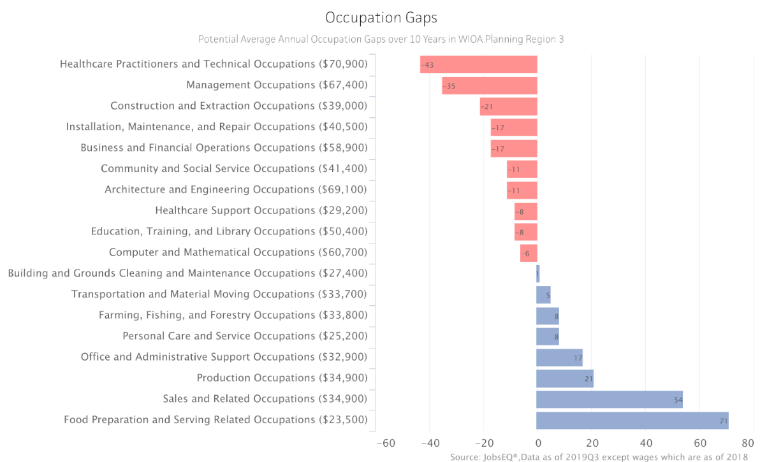

- An assessment of what sectors/industries are considered mature but still important to the regional economy, current and in-demand, and which are considered emerging in the regional economy.
Accommodation and Food Services is a mature industry due to the length of time it has served as a primary economic driver in the region. While many “staple” businesses have survived the emerging and growth stages of an industry cycle, there continue to be new businesses, as well as failures, in this volatile sector. However, the industry continues to provide a significant proportion of the region’s jobs. It is expected to continue to serve as an economic driver, although it is suffering now due to COVID-19. Partially due to the high volume of jobs, as well as the nature of those occupations, turnover is relatively high and thus there are typically numerous job openings. Prior to this global pandemic, most hotels, restaurants, and other tourism-related businesses had extreme difficulty filling their vacant positions.
Forestry and Wood Products Manufacturing are complementary industries that are growing in the region. While they were emerging before, their growth took on new momentum upon the opening of ARAUCO Worldwide, a particle board manufacturing company located in Grayling. This company’s decision to locate in the region added hundreds of jobs, and spurred the growth of related companies that harvest and grade lumber, transport it to manufacturing facilities, and transform it into usable products.
It is difficult to predict which industries will not only survive the COVID-19 crisis but also emerge with new growth. Based on anecdotal information, the region believes that the following industries are positioned to grow in the aftermath of the crisis.
- Transportation and Logistics: This was already an in-demand industry, and is all the more so now with a significant increase in online purchases.
- Information Technology: As more work is conducted virtually, additional services will be needed to manage the equipment, infrastructure, security, and more.
- Healthcare Equipment Manufacturing: The disruption in the supply chain for Personal Protection Equipment early in the crisis revealed a weakness in relying on non-American suppliers. Therefore, more companies will likely pivot to this production and will continue to do so after the crisis subsides.
- Various types of Manufacturing, such as Chemical and Transportation Equipment: As new consumer needs arise, local companies will diversify and new manufacturing companies may start in order to meet the need.

- The knowledge and skills necessary to meet the employment needs of the employers in the region, including employment needs of in-demand industry sectors and occupations.
The skill needs of employers within demand industries are determined through a combination of labor market data, job postings, and information directly from local businesses. Business solutions representatives within workforce programs (MWAs, MRS, Veterans Services) establish ongoing relationships with employers throughout the WIOA region, maintaining a high level of local intelligence regarding their needs.
Healthcare is a growth industry that will require workers across a wide range of skill levels. On the entry-level end of the range are Personal Care Aides (home health), Certified Nurse Aides, and Pharmacy Techs. These occupations typically require a high school diploma and some postsecondary training; the C.N.A. occupation requires state licensure. In the middle range are technicians, including Surgical and Radiologic Technologists, which require an associate’s degree and state licensure. Highly skilled in-demand positions include Registered Nurses, requiring at least an associate’s degree with more and more healthcare systems requiring a bachelor’s degree. Skills that are necessary across most healthcare jobs include medical terminology, anatomy and physiology, first aid and CPR, and universal precautions.
Manufacturing companies are in need of entry-level production workers, as well as Machine Operators and Programmers requiring training ranging from on-the-job training to an associate’s degree. The manufacturing industry also needs mid-level skilled technicians with cross-training to address machine repair and operation, requiring knowledge in hydraulics, robotics, electrical, and more. In addition, Welders are needed with American Welding Society certification in multiple types of welding.
The Transportation and Warehousing industry needs Long-Haul Truck Drivers; with increased use of online purchasing, this industry will require more workers with CDL certification as well as myriad endorsements. Also, more local retailers are providing delivery services, so regional transportation will likely grow in the aftermath of COVID-19.
Construction companies need workers with the ability to install HVAC and electrical, measure and cut accurately, frame and finish carpentry, and follow safety regulations. Although construction typically is seasonal, workers with cross-functional skill sets will be highly sought after to work on outside projects in the summer and indoor in the winter.
The Retail Trade and Accommodation and Food Service industries require workers with a high school diploma, unless hiring for management or skilled positions, such as Executive Chef. Most of the employers in these industries need employees with good customer service skills.
Regardless of industry or occupation, all employers in the region cite the need for workplace literacy skills. Also referred to as “soft skills” but not to be diminished, these skills are truly critical to success on any job. Those most often required include attendance and punctuality, positive and professional attitude, respect for authority, and the ability and commitment to hard work.
An expansion of the list of employability skills is anticipated due to the impact of COVID-19. Many businesses discovered during the “Stay Home” period that virtual work was not only feasible, but may be preferable for some occupations. The skills needed for those who can and will continue to work from home include high levels of technology literacy so they can trouble-shoot on their own. Also, the ability to communicate effectively over video conferencing will be needed, although it has to be well-defined.

- The demographic characteristics of the current workforce and how the region’s demographics are changing in terms of population, labor supply, and occupational demand.
The 14-county region’s population has fallen slightly since 2013, by 0.6%, while both the state and nation have increased. This reflects the trend in most counties, with Arenac showing the biggest percent decrease at 3.4%. Otsego county had the largest percent and numeric increase, at 2.5% and 590 people. This is in keeping with industry growth in Gaylord, the seat of the county.
Table 4: POPULATION TRENDS, 2013–2019
AREA | 2013 | 2015 | 2017 | 2019 | 2013–2019  NUMERIC CHANGE | 2013–2019  PERCENT CHANGE
WIOA Region | 275,984 | 274,154 | 273,399 | 274,369 | -1,615 | -0.6%
Alcona | 10,554 | 10,330 | 10,309 | 10,405 | -149 | -1.4%
Alpena | 28,957 | 28,722 | 28,428 | 28,405 | -552 | -1.9%
Arenac | 15,413 | 15,307 | 15,014 | 14,883 | -530 | -3.4%
Cheboygan | 25,573 | 25,399 | 25,454 | 25,276 | -297 | -1.2%
Clare | 30,600 | 30,616 | 30,565 | 30,950 | 350 | 1.1%
Crawford | 13,877 | 13,853 | 13,906 | 14,029 | 152 | 1.1%
Gladwin | 25,565 | 25,227 | 25,241 | 25,449 | -116 | -0.5%
Iosco | 25,427 | 25,343 | 25,128 | 25,127 | -300 | -1.2%
Montmorency | 9,378 | 9,287 | 9,233 | 9,328 | -50 | -0.5%
Ogemaw | 21,160 | 20,877 | 20,882 | 20,997 | -163 | -0.8%
Oscoda | 8,369 | 8,277 | 8,238 | 8,241 | -128 | -1.5%
Otsego | 24,078 | 24,203 | 24,528 | 24,668 | 590 | 2.5%
Presque Isle | 13,010 | 12,801 | 12,742 | 12,592 | -418 | -3.2%
Roscommon | 24,023 | 23,912 | 23,731 | 24,019 | -4 | 0.0%
Michigan | 9,913,065 | 9,931,715 | 9,973,114 | 9,986,857 | 73,792 | 0.7%
United States | 315,993,715 | 320,635,163 | 324,985,539 | 328,239,523 | 12,245,808 | 3.9%
Source: U.S. Bureau of the Census, Annual Population Estimates

Although the overall population decrease is a cause for concern, it is an improvement over previous reports. In 2018, the six-year percent change was -2.0%, or 5,431 people. Although this improvement appears minimal, it is still significant given the low population of the region.
In order to understand the changes at a deeper level, it is important to explore variations in the population by demographic group, as Figure 2 displays. It is clear to see that the bulk of the population decline is in working age groups, with those near or after retirement increasing. This results in increased need for goods and services by those in the older age ranges, with fewer workers available to meet these needs.
Figure 2: Change in Population by Age Range
Source: JobsEQ, American Community Survey, 5-year estimates ending with the years shown in title

Overall, the population is projected to decline slightly (-0.3%) between 2020 and 2030. However, individual county changes range from a high of 9.6% increase in Otsego to a low of 7% decrease in Arenac.
Michigan Bureau of Labor Market Information and Strategic Initiatives (BLMISI), Population Projections Report, 2019
Figure 3: Projected Change in Population by County, 2020 – 2030

- An analysis of the current workforce in the region, including employment and unemployment data, labor market trends, and the educational and skill levels of the workforce, including individuals with barriers to employment.

Labor Force Information
Table 4 displays labor force information by county, subtotaled by local area with data as of December 2019. The unemployment rate varies greatly by county, especially in the Michigan Works! Northeast Consortium area. This area is home to counties with both the highest and lowest unemployment rate: Alpena at 4.3% is the lowest, while Cheboygan is the highest at 11.8%. This is in keeping with the seasonal nature of Cheboygan county’s tourism-related economy, and Alpena’s emphasis on manufacturing.

Table 5: Labor Force and Unemployment Rate (Dec. 2019) – WIOA Region 3
Area | Labor Force | Employed | Unemployed | Unemployment Rate
Alcona County, MI | 3,658 | 3,418 | 240 | 6.56%
Alpena County, MI | 13,308 | 12,736 | 572 | 4.30%
Cheboygan County, MI | 10,100 | 8,908 | 1,192 | 11.80%
Crawford County, MI | 5,644 | 5,305 | 339 | 6.01%
Montmorency County, MI | 3,080 | 2,788 | 292 | 9.48%
Oscoda County, MI | 3,001 | 2,779 | 222 | 7.40%
Otsego County, MI | 11,378 | 10,861 | 517 | 4.54%
Presque Isle County, MI | 4,959 | 4,560 | 399 | 8.05%
Totals - MW!NC | 55,128 | 51,355 | 3,773 | 6.84%
Arenac County, MI | 5,816 | 5,417 | 399 | 6.86%
Clare County, MI | 11,828 | 11,111 | 717 | 6.06%
Gladwin County, MI | 9,943 | 9,386 | 557 | 5.60%
Iosco County, MI | 9,888 | 9,283 | 605 | 6.12%
Ogemaw County, MI | 7,979 | 7,429 | 550 | 6.89%
Roscommon County, MI | 7,653 | 7,091 | 562 | 7.34%
Totals - Region 7B | 53,107 | 49,717 | 3,390 | 6.38%
Totals - WIOA Region | 108,235 | 101,072 | 7,163 | 6.62%
Source: U.S. Bureau of the Census, Annual Population Estimates

The unemployment rate in the 14-county region has steadily declined since its peak in 2009. Figure 3 shows seasonally adjusted unemployment rates from 2008 to November 2019. Unfortunately, recent unemployment rates have skyrocketed due to COVID-19, and as of April 2020 range from a high of 41.2% in Cheboygan County (the highest in the state) to a low of 18.6% in Alpena County.
Figure 4: Unemployment Rate Trends, 2008 – 2019
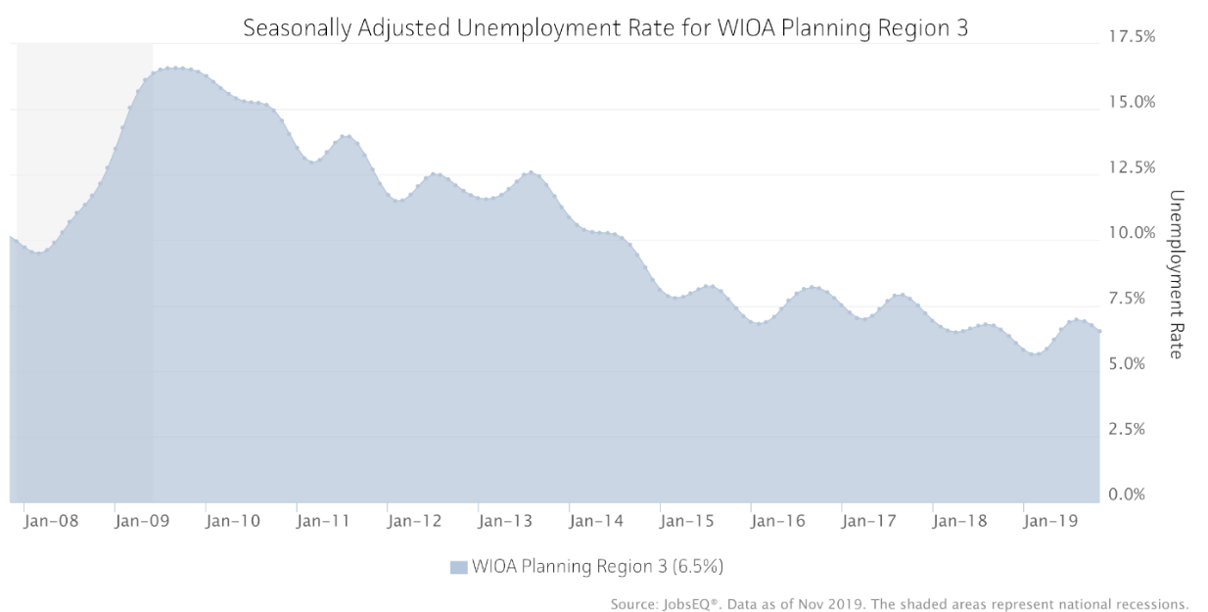

Educational attainment has remained relatively flat in the region, with some decrease of those with only a high school diploma, and slight increases in associate’s and bachelor’s degrees. Still, the region has a high proportion of individuals with only a high school diploma, at 36.6% as of 2018, and those with less than a high school diploma at 10.0%. According to the U.S. Census Bureau American Community Survey, 5-year estimate 2014-2018, individuals in the state of Michigan with a high school degree was 29.0% and less than a high school diploma was 9.5%. The region is faring worse than the state overall when it comes to educational attainment, making it difficult to attract businesses with higher skill needs.
Figure 5: Educational Attainment, 2012 – 2018

Source: JobsEQ, American Community Survey, 5-year estimates ending with the years shown in title

Educational attainment is one indicator of skill level, but specific skill sets that match occupations within the region is another means of assessing the workforce. Figure 5 displays skill gaps identified for the region during 2019. Because the Retail Trade and Accommodation and Food Service industries are so prevalent in the region, several skills listed here reflect the needs of those industries.
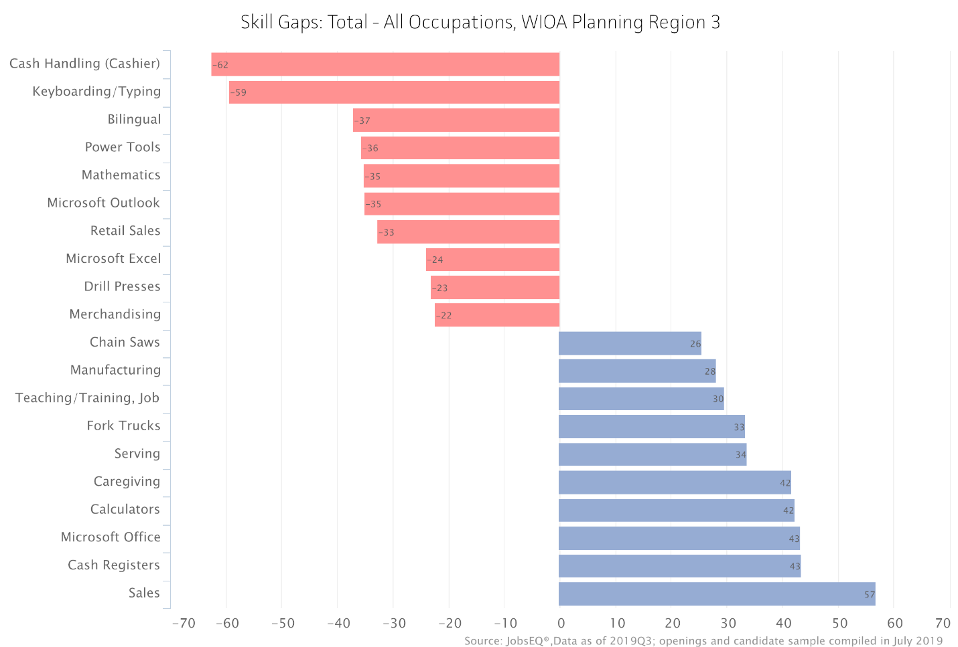
Figure 6: Skill Gaps

Individuals with Barriers to Employment
The proportion of individuals with a disability is slightly higher in the region than the state average, and is growing. This may be due to the increase in retirement-age individuals, who are more likely to experience a physical impairment that interferes with daily activity.
Figure 7: Individuals with Disabilities, 2013 – 2018

Source: Michigan Bureau of Labor Market Information and Strategic Initiatives

Individuals on public assistance has changed over time as well. While the region remains higher than the state average, there has been a significant decrease in those receiving income or other types of assistance, such as childcare and food. There are a number of potential reasons for the change, including the implementation of lifetime limits, the existence of more jobs, and the slight increases in educational attainment displayed in Figure 5.
Figure 8: Change in Public Assistance, 2013 – 2018

Source: Michigan Bureau of Labor Market Information and Strategic Initiatives

Even while use of public support has decreased, poverty has increased, and so has the number of families living under the cost-of-living threshold. Described as the ALICE population – Asset Limited, Income-Constrained, Employed – these families are above the poverty line, but working and yet still struggling to make ends meet. It is likely that this group was most impacted by COVID-19, as their jobs are often in service occupations.
Figure 9: Poverty Levels and ALICE Households, 2010 – 2017

Source: Michigan Association of United Ways, ALICE Report by County, 2019

- An analysis of workforce development activities in the region, including available education and training opportunities. This analysis must include the strengths and weaknesses of workforce development activities in the region and the region’s capacity to provide the workforce development activities necessary to address the education and skill needs of the workforce, including individuals with barriers to employment, and the employment needs of employers in the region.
AND
- A discussion of geographic factors (inherent geographic advantages or disadvantages) that may impact the regional economy and the distribution of employers, population, and service providers within the region.

The workforce development system in the region consists of multiple agencies and programs. Together, they form a network of services that prepare and maintain a skilled workforce to meet employer needs. The system consists of four domains of services:
- Education, including CTE, general K-12, adult education (GED/HSE), and postsecondary certificate and degree programs, as well as combinations thereof such as dual enrollment and middle college.
  - Providers in this domain include all K-12 school systems; four ISDs; Iosco-RESA Adult Education; Alpena Community College; Kirtland Community College; North Central Michigan College; Mid-Michigan Community College; Industrial Arts Institute; and several private sector postsecondary training providers.
- Workforce Programs, including career exploration and planning, case management, job search assistance, work-based training, funding for occupational training provided by the education sector, workplace readiness, training on self-advocacy, and connections to local employers. Specialized services are provided to opportunity youth, veterans, individuals and youth with disabilities, individuals on public assistance, offenders, migrant and seasonal farmworkers (MSFW), and more. Programs include, but are not limited to: WIOA Adult, Dislocated Worker, and Youth; Employment Services including Veterans Services and MSFW; PATH/TANF; Vocational Rehabilitation; Trade Act (all acts); and Jobs for Michigan’s Graduates.
  - Providers in this category include Michigan Works! Northeast Consortium (MW!NC); Michigan Works! Region 7B (Region 7B); and programs under the Michigan Department of Labor & Economic Opportunity (LEO): Michigan Rehabilitation Services, Bureau of Services for Blind Persons, Veterans Services, and Migrant & Seasonal Farmworker Program.
- Supportive Services, including public assistance for food, childcare, income, utilities, and more; unemployment compensation; transportation services; food pantries; domestic violence shelters; and many other programs that assist individuals and employers to remove barriers to successful, long-term employment.
  - Providers in this domain include the Michigan Department of Health & Human Services (DHHS); LEO-Unemployment Insurance Agency; Northeast Michigan Community Services Agency (NMCSA); local transit authorities; and more.

- Business Services, including economic development incentives and supports like site selection and growth; business planning and counseling; access to government contracting; training for new hires and incumbent workers; access to overlooked talent pools including veterans and those with disabilities; coaching on accommodations for individuals with disabilities; retention services to reduce turnover; and work-based training programs, such as apprenticeships, on-the-job training, and incumbent worker training.
  - Providers in this domain include economic development entities covering all counties; Small Business Development Center; and Procurement Technical Assistance Center; MRS; SafetyNetWorks (BRN administered by MW!NC); and The Network (BRN administered by Region 7B). In addition, providers in most other domains work closely with employers to better understand their needs and support their workforce, including both MWAs, Veterans Services, MRS, and CTE programs. All community colleges in the region have capacity to customize training programs for local employers.

Education and training activities are available for most in-demand industries and occupations. At the postsecondary level, the four community colleges, University Center, and private training providers offer the following programs for in-demand industries (this list is not all-inclusive):
Healthcare | Manufacturing | Construction and Trades | Information and Professional
- Certified Nurse Aide  - Registered Nurse  - Health Information Technology  - Surgical Tech  - Medical Assistant | - Manufacturing Technology  - Mechatronics  - CNC Machining  - Automation and Robotics | - Welding  - Automotive  - HVAC  - Concrete Technology  - Utility Line Tech  - Electrical Systems | - Computer Information Systems  - Management  - Computer Aided Design

Career and Technical Education (CTE) programs are offered by eight ISDs and/or local districts. The programs prepare students for most in-demand industries, and are designed to respond to the needs of industry within each community. Several programs offer industry-recognized credentials and/or college credit, some through early or middle college. Many of the programs listed above at the postsecondary level are also available through CTE programs; the programs work together to offer a career pathway with increasing skill levels and access to local employers.
The primary Adult Education program offered throughout the region is administered by Iosco-RESA. Adults can access services at any location to upgrade basic academic skills, improve computer and workplace literacy, and prepare for their GED, HiSET, or other high school equivalency exam.
The top 20 awards – certificates and credentials – earned during the 2018-2019 school year are presented in Table 6. (The Total listed at the top represents all awards and includes those beyond the top 20.) These indicate not only the availability and accessibility of programs matched to high-demand occupations, but also the region’s ability to prepare a skilled workforce.
Table 6: Top 20 Awards by Program (2017-2018) – WIOA Region 3
CIP Code | Title | Certificates and 2yr Awards
 | Total | 1,140
51.3801 | Registered Nursing/Registered Nurse | 171
24.0101 | Liberal Arts and Sciences/Liberal Studies | 143
52.0201 | Business Administration and Management, General | 120
46.0303 | Lineworker | 80
43.0107 | Criminal Justice/Police Science | 40
47.0604 | Automobile/Automotive Mechanics Technology/Technician | 33
48.0508 | Welding Technology/Welder | 31
47.0201 | Heating, Air Conditioning, Ventilation and Refrigeration Maintenance Technology/Technician | 28
51.9999 | Health Professions and Related Clinical Sciences, Other | 26
24.0103 | Humanities/Humanistic Studies | 24
13.1210 | Early Childhood Education and Teaching | 22
24.0199 | Liberal Arts and Sciences, General Studies and Humanities, Other | 21
51.0801 | Medical/Clinical Assistant | 21
51.0901 | Cardiovascular Technology/Technologist | 20
51.0907 | Medical Radiologic Technology/Science - Radiation Therapist | 17
51.3901 | Licensed Practical/Vocational Nurse Training | 16
24.0102 | General Studies | 15
48.0507 | Tool and Die Technology/Technician | 15
15.0201 | Civil Engineering Technology/Technician | 14
51.0909 | Surgical Technology/Technologist | 14
Source: JobsEQ®
Data as of the 2017-2018 academic year, related occupation data as of 2019Q3 except wages which are as of 2018.

Strengths and Weaknesses
The region identified several strengths and weaknesses within the workforce development system. The Regional Service Strategies section below uses these strengths to mitigate weaknesses and turn disadvantages into opportunity.

Strengths
- Partnerships and Collaboration: The region’s service providers have a long history of strong partnerships, resulting in collaborative efforts that stretch limited resources.
- Customer Service: Because the region is largely rural, many of the providers serve as community hubs, enabling connections and access to resources that would otherwise be unavailable. As one WIOA partner stated during the regional planning process, “the community knows we care.”
- Resourcefulness: With such small population numbers, formula-based funding for many programs is limited, and does not always provide adequate resources for the unique needs of rural residents. Therefore, partnerships have formed out of necessity, and have stayed strong in order to ensure that the most resources get directly to the customer.
- Business Engagement: Small businesses (2 to 9 employees) make up a vast majority of companies in the region, with at least 60% of the total of all establishments in all counties as of 2019. These companies are eager to engage with workforce development programs, due to their limited capacity for human resources functions. Therefore, the collection of providers in the workforce network is well-connected with employers, maintaining a high level of local intelligence about business needs.
- Strong Education System: Despite the small size of most local districts, CTE programs, and postsecondary programs, educational outcomes are strong. All educational institutions are dedicated to providing the best education possible for local students, and connecting them to opportunities for continued education and local employment.
- Co-Location: While customers of the American Job Centers have meaningful access to all WIOA Required Partners through some means of technology and/or direct referral, many partners have chosen to co-locate within one or more AJCs, or utilize itinerant space. This includes Veterans Services, UIA, MRS, Offender Success, and Adult Education. Co-location strengthens partnerships because frontline staff become familiar with each other and the programs and services offered.

Weaknesses
Many of the weaknesses held by the workforce development system are due to the geography of the region. The population of slightly less than 275,000 people is spread across a large expanse of 7,865 square miles. Together the 14 counties are larger than the state of Massachusetts. This causes several challenges to service delivery for all domains.
- Educational opportunities are constrained, despite the relatively large number of programs and providers, due to geography. For instance, CTE programs are delivered in a scattered site model, because there isn’t enough capacity for a centralized location. Therefore, if a student lives too far from the program of their choice, they cannot attend because of the vast travel distance required.
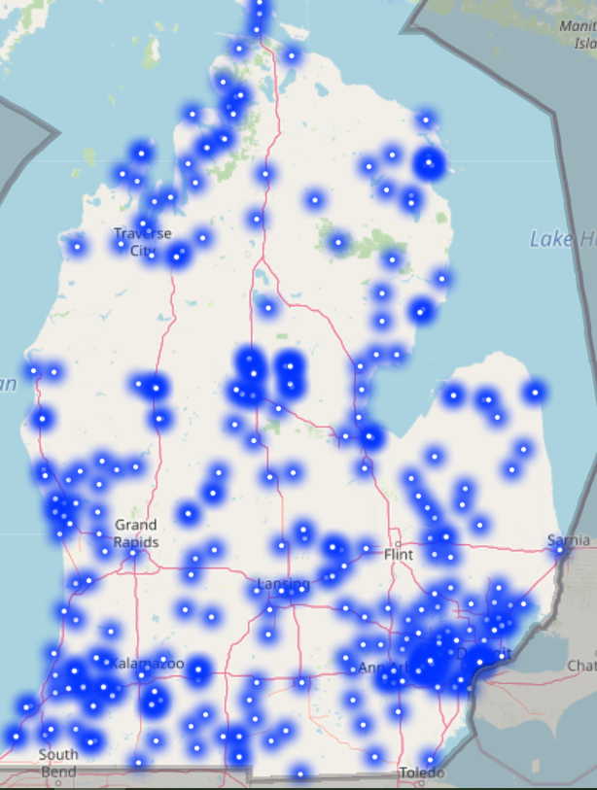
- Transportation options are very limited. County-based transit authorities exist only in some counties, with limited service. The low population density does not support the full range of transportation services. Therefore, individuals typically use their own vehicles for transportation to and from work. If their income does not support a reliable vehicle and ongoing maintenance, their ability to report regularly and on time is greatly reduced.
Figure 10: Free Wifi Hotspot Availability
- Lack of broadband internet service is a significant challenge for small businesses, entrepreneurs, and students. With the onset of COVID-19, more and more virtual work is occurring, but lack of internet access is a prohibiting factor. Because the business model for broadband providers relies on volume to overcome the high costs of building the infrastructure, very few communities in the region meet the necessary critical mass. Figure 10 to the right displays availability of free wifi hotspots in various communities around the state, but WIOA Region 3 has large swaths where that service is not available. (Source: Connected Nation Michigan)
- The region’s youth leave for bigger cities and an exciting lifestyle with more people, amenities, activities, and opportunities.
In addition to the challenges presented by the geography and small cities, other weaknesses were identified during the planning process as follows:
- High ALICE population
- Limited higher wage job opportunities
- Demographics: more individuals are leaving the workforce than entering
- High housing costs in shoreline areas
- Lack of affordable, available childcare
- Lower educational attainment than the state average
- Lack of a strong, unified voice in Lansing

Capacity
Both the strengths and weaknesses shown above impact the capacity of the region to meet the needs of local employers, and to help those with barriers to employment. While services are excellent and well-connected to both employer and job seeker needs, the ability to deliver those services to all who could benefit is hindered. The Weaknesses section provided much detail regarding limitations due to geography, but another factor in diminished capacity is funding. Additional funding would provide capacity to expand in underserved communities and assist more people with higher quality and targeted services. This is especially important for serving individuals with barriers to employment, as they require more individualized attention, longer-term relationships with staff, and more supportive services. Additional training dollars would prepare more workers for current and future demands, and support the higher costs of work-based training such as work experience and apprenticeships.
Additional capacity can be achieved through enhanced partnerships. Although the region is very strong in collaboration and relationships across all providers, there is always room for improvement. As you will see in the section below, several regional strategies leverage the collaborations existing in the region. Additional coordination will allow for a more streamlined experience for customers and more capacity to reach both job seekers and employers.

Regional Service Strategies
3. A description of regional service strategies that have been or will be established as a result of coordinated regional analysis and delivery of services, including the use of cooperative service delivery agreements, when appropriate.
Based on the comprehensive regional planning process conducted to develop this plan, the following goals and corresponding strategies were established. These strategies make extensive use of the strengths of the region, including Partnerships and Collaboration and Business Engagement. Many of the strategies work to mitigate the impact of the weaknesses related to the geography of the region.
Goal | Strategies
Utilize employer-led collaboratives to address systemic barriers to long-term, sustainable employment | - Educate the local business community about ALICE households and the economic challenges they face.
 | - Educate the local business community about transportation, childcare, and housing barriers for the workforce.
 | - Expand Business Resource Networks across the region.
- Mobilize employers in BRNs, sector groups, and industry associations to work together in overcoming barriers with projects such as:
  - Collaborative childcare centers,
  - Ride-sharing or company-provided transportation, and
  - Tiny home communities.

Leverage the strong collaborative spirit in the region to increase resources, improve services, and ensure efficiency | - Learn more about each other by providing joint orientations and engaging in shared professional development (when appropriate).
 | - Work together to identify and pursue grants, philanthropic funding, and other resource opportunities.
 | - Create marketing partnerships to align messaging and unify the voice of the region’s workforce system.
Increase transportation capacity for the local workforce | - Explore rural ride-sharing models and test them with pilots in the region.
 | - Pursue support from automakers, local employers, and other agencies to sponsor workforce transportation.
Increase awareness of local career opportunities among youth and families | - Continue the momentum of MiCareerQuest, Talent Tours, job shadowing, and other career exploration events by engaging with more employers and schools and increasing outreach to students.  - Develop and promote MiCareerPathways.
 | - Pursue a variety of funding opportunities to support career-focused staff in schools across the region.
Enhance talent attraction and retention through coordinated regional marketing and advocacy | - Participate in and support regional branding efforts for talent attraction.
 | - Partner with and support economic development initiatives which may include increasing broadband availability.
 | - Provide more and better opportunities for career advancement, including earn-and-learn models such as apprenticeships and on-the-job training.

Several of the above strategies already have momentum due to existing or newly established projects; some have cooperative service agreements and local collaborations in place. For instance, Business Resource Networks are currently active via both MWAs, and will seek expansion in the coming four years. These networks will be essential to addressing systemic issues, such as transportation, mental and emotional health, and childcare. In addition, they focus on supporting hard to serve populations with retention strategies.
Another means of addressing systemic issues across the region is through sector-based groups. These are currently in place for Manufacturing, Transportation, Human Resources, Non-Profits, Healthcare, and Construction. The groups meet regularly to identify common business needs, including workforce issues. These groups are leveraged extensively for multiple initiatives and programs, and will be instrumental in creating solutions for large-scale barriers to employment.
The Regional Prosperity Initiatives in prosperity regions 3 and 5 cover the WIOA region, and include economic development relationships to promote the area as a talent and business destination, as well as initiatives to increase broadband availability. The RPIs are currently focused on short and long-term strategies for recovery from COVID-19 and infrastructure needs due to catastrophic flooding. These discussions include issues related to talent and workforce needs, as well as critical supports for the workforce, such as childcare availability. Expanding broadband access has risen to a high-level priority.
Another set of collaborations involves serving youth within the region. The Marshall Plan for Talent supports career navigators in several school districts, and Jobs for Michigan’s Graduates and WIOA Youth programs partner with high schools and CTE programs. Both MWAs and MRS are actively working with youth in the region to provide valuable work experience opportunities, career planning, employment coaching, and transition services. In addition, the workforce development system in the region commits to supporting the state’s Priority #3 in the state Unified Plan: Summer Young Professionals Program, in an effort to ensure that young people gain relevant experiences in the real world of work, preparing them for in-demand opportunities.
To increase work-based learning opportunities, along with informing youth and job seekers about local, in-demand careers, the MiCareerPathways program is in development. MW!NC and Region 7B are collaborating to convene this project, and will incorporate many other partners, including MRS and Adult Education as the program gets under way. This activity supports the Governor’s Sixty by Thirty Initiative (and Priority #2 in the Unified State Plan), with a goal of increasing statewide postsecondary educational attainment to 60% by 2030. Mapping the career opportunities, including their necessary educational milestones, will improve awareness and connection to appropriate training programs.
In addition to the above, the following existing collaborations will be leveraged and/or expanded in order to pursue the regional strategies. Specifically, these efforts include the following:
- Kirtland Community College employs an apprenticeship coordinator, who works closely with workforce development programs and local employers to increase utilization of the apprenticeship model.
- MW!NC and Region 7B work together to provide services to dislocated workers from the hard-hit retail industry through the State of Michigan’s Trade and Economic Transition National Dislocated Worker Grant. This grant was recently expanded to include dislocations from the manufacturing industry.
- The two MWAs have aligned their business services with shared policies and forms to better serve employers that cross their boundaries.
- WIOA Core partners and most other partners are involved in county-based human services collaboratives, working together to leverage resources, share information, and find opportunities for joint planning and improved coordination.
- MRS regularly provides training to various partners, so they are better educated about the needs of individuals with disabilities, as well as services available to them.
- Career and Education Advisory Councils are active in both local areas, and represent the full range of educational opportunities, along with private sector and workforce.
- The MiSTEM regional networks are well-connected within the workforce system, and participate on both Career and Educational Advisory Councils.
- Integrated Education and Training programs connect the MWAs with the Adult Education system, offering work-based learning to contextualize education.
- All workforce development professionals at WIOA Core Partners who primarily serve employers are trained in the Certified Business Solutions Professional approach. These include Business Solutions Representatives at both MWAs, Business Relations Consultant at MRS, and Local Veterans Employment Representative at Veterans Services within LEO. These staff across the region communicate regularly in order to coordinate connections with businesses.
- MOUs exist with all required WIOA Partners, and IFAs reflect use of the AJCs and/or relative benefit to program customers.

Sector Initiatives
4. A description of plans for the development and implementation of, or the expansion of, sector initiatives for in-demand industry sectors or occupations for the region.
One of the key ways that the region will engage in-demand industry sectors is through the development of MiCareerPathways. Led by the two MWAs, but including partners such as Adult Education, MRS, training providers, and local employers, this project will map career pathways in the region. The goal of the project is to enhance the ability of education, workforce, and employer partners to successfully fill the talent pipeline in key industry sectors.
The initiative will start in 2020 by convening representatives of the Manufacturing sector. This sector will serve as a pilot for developing and documenting the process. Engagement of representatives will consist of career pathway-specific meetings and focus groups. All partners will contribute as appropriate to their role: MWAs will collect and share labor market data as well as convene and coordinate the project, education partners will provide data on completion rates and new program viability, and private sector partners will describe their skill requirements and projected hiring. This collaboration will be facilitated and managed to ensure that all partners are doing their part, deadlines are met, and outcomes are achieved. Together, the partners will define existing pathways and simultaneously identify gaps that must be addressed in order to meet employer needs.
Ultimately, the pilot team will create a clearly articulated career pathway for the Manufacturing sector. This will include wage, outlook, education/credentials, local and regional employers. The results of the process will be a printable but primarily web-based product. It will allow for easy access and sharing across partners and consumers. Using the same model, additional sectors will be engaged to develop the same product.
In addition to the MiCareerPathways project, sector strategies will be utilized as follows:
- Existing Industry Associations: both MWAs have representation and connection to existing industry associations. These include associations for the following sectors: Manufacturing, Transportation, Human Resources, Non-Profits, Healthcare, and Construction.
- MiCareerQuest, Talent Tours, and Career Expos: All career awareness and exploration events are conducted with a sector framework, allowing companies to work together to promote their industry to the future workforce.
- Industry-Led Consortium trainings: The GoingPro Talent Fund provides support for groups of companies with similar training needs to collaborate on a training project. This approach to training brings together a sector to work with education providers and create a training that meets their needs. This approach is also available through WIOA-funded Customized Training and Incumbent Worker Training.
- Apprenticeships: The region has increased its promotion of USDOL Registered apprenticeships and will continue to work with employers within a sector to access this highly effective workforce training mechanism.
All of the above sector-based initiatives will be more important than ever during the recovery from the COVID-19 crisis. Companies that work cooperatively to address their workforce and other business needs will benefit from the targeted approach, ensuring a continuous pipeline of skilled talent.

Administrative Cost Arrangements
5. A description of any administrative cost arrangements that currently exist or that will be established within the region, including the pooling of funds for administrative costs, as appropriate.
Current administrative cost arrangements in the region include:
- MRS has inter-agency cash transfer agreements with most ISDs in the region, to ensure ready access to supports for students in Pre-Employment Transition Services.
- Michigan Works! Region 7B has formal agreements with the economic development entities in the following counties. The agreements consist of a shared position covering each location to provide workforce and economic development services:
  - Arenac
  - Clare
  - Gladwin
  - Ogemaw
  - Roscommon
- Several Michigan Works! offices offer rental space for other agencies in the region. In some cases, there is an agreement with the other agency of shared responsibility when assisting clients. For instance, the United Way is located in Roscommon’s AJC, a representative from Disabled American Veterans has office space in Clare and Gladwin AJCs, the Women’s Aid program is offered at the Clare AJC, and the Procurement Technical Assistance Center for the Northeast region is hosted in Onaway.
- Infrastructure Funding Agreements are in place for all WIOA Required partners, based on co-location or relative benefit, using the agreed-upon methodology across all MWAs. The Region 7B Michigan Works! agency pays NEMC infrastructure costs based on IFA methodology for its use of their centers in providing Offender Success services.

- The two MWAs have a history of sharing administrative costs for specific projects. Current examples include the Trade and Economic Assistance grant, development of this regional plan, and a recently requested National Dislocated Worker grant based on the opioid disaster.

Coordination of Transportation and other Supportive Services
6. A description of how transportation and other supportive services, as appropriate, currently are coordinated or will be coordinated within the region.
During the comprehensive process of developing this regional plan, stakeholders identified a lack of transportation as one of the most significant challenges facing the workforce today. The large geography of the region makes access to reliable and affordable transportation an absolute necessity, but the low population volume does not meet critical mass for large-scale transit systems. The vast majority of workers use personal vehicles to get to work, but the high proportion of ALICE households have difficulty maintaining a functioning vehicle.
The lack of transportation results in substantial losses for both the workforce and local employers. Job seekers are limited in how far from home they can look for job opportunities. Potential youth participants may not be able to participate in work experience programs because the household has only one functioning vehicle, to be used by the working adult. Businesses have difficulty recruiting from farther distances where they may be able to find a skilled employee. And once employed, workers may experience car trouble which causes tardiness, poor attendance, and financial stress, reducing productivity for the business.
Currently, all partners in the workforce system recognize the severity of this issue, and work collaboratively to provide as much support as possible. This support typically consists of mileage reimbursements, gas cards, bus tokens, car repair, and sometimes auto or bicycle purchase. In addition, workforce programs supply information to participants about public transit, where it is available, including routes, and schedules. All transit providers ensure that their busses and pick-up service vehicles are accessible to individuals with disabilities. Coordination by frontline staff across numerous agencies is achieved through human services collaborative councils, where the issue is discussed and resources are shared and leveraged wherever feasible.
The Regional Strategies section of this plan identified strategies for addressing the issue in the future. The region will work collaboratively to enact these strategies, with the primary goal of Increasing transportation capacity for the local workforce.
- Explore rural ride-sharing models and test them with pilots in the region. This strategy recognizes that personal automobiles are likely to continue as the primary means of transportation to and from work. However, with high costs of owning and maintaining a vehicle, ride-sharing could be a viable option. This could be similar to existing ride-share programs such as Uber or Lyft, but for the workforce in a rural area, or it could consist of pools of workers in the same vicinity taking turns to carpool. Regardless, the effort has been tested in other areas of the country, so the first step in this strategy will be to research those programs to identify promising practices and lessons learned.
- Pursue support from automakers, local employers, and other agencies to sponsor workforce transportation. This strategy expands the network of support beyond the workforce system to others who have a vested interest in successful transportation systems. Support could take the form of sponsoring a ride-share or carpool program, offering additional mileage reimbursement funds, or providing incentives for coordinating transportation.
In addition to the above strategies, the Regional Prosperity Initiatives (Prosperity Regions 3 and 5) covering WIOA Region 3 are focused on transportation as a critical component of economic success. The 10-year plan developed for Prosperity Region 3 (the 11 northern counties of the WIOA region) identified the following goals and strategies related to transportation:
Goal: Develop or enhance transportation options across the region for efficiency and accessibility
- Strategy: Increase awareness of existing transportation options and resources for the workforce
- Strategy: Collaborate and coordinate across sectors to reduce costs for logistics and workforce transportation
These align with the regional workforce goals and strategies, as well as the state’s goals of supporting individuals with barriers to employment, as expressed in the State Strategies section of the Unified State Plan. Coordination across multiple entities working to improve transportation options will be a significant undertaking, but one that is already well developed and positioned for success due to the high levels of collaboration across the region.
All of the above transportation-related strategies will likely be most effective if relying on collaborative groups of employers, such as industry associations or Business Resource Networks. Combining these efforts with sector approaches will help to streamline this and other strategic activities, allowing the region to pursue its goals despite having limited capacity.
Coordination of transportation and other supportive services occurs at multiple levels. As discussed above, leadership is regularly assessing transportation options and creating strategies to address it. On the frontline, staff are working together every day to coordinate resources. Staff at MRS and both Michigan Works! Agencies must seek comparable benefits from other agencies before using workforce program funds to provide any kind of supportive service. Provision of supportive services is always based on an individual’s need to overcome barriers. This customized, coordinated approach not only stretches limited resources; it also ensures that staff are maintaining high levels of communication and program knowledge across many partners.
Although transportation is one of the highest used supportive service, others are provided - when needed - to reduce barriers to participation in workforce programs and activities. Job seekers experience a variety of barriers, such as lack of quality and available childcare; physical, mental or emotional disabilities; lack of soft skills; poverty that results in limited or substandard food supply, housing, clothing, and medical care; domestic violence; and many more. Assistance for all of these issues is available throughout the region, but is more available in population centers, which makes access difficult for those in very rural areas. Due to the COVID-19 crisis, supportive services are also provided for internet access, including hot spots for participants located in areas without reliable broadband.
Numerous partners provide supportive services across the region. These partners include, but are not limited to: MW!NC, Region 7B, MRS, Department of Health and Human Services, Goodwill, Northeast Michigan Community Services Agency (NMCSA), Mid-Michigan Community Action Agency, United Way, Salvation Army, food pantries, churches, and more.
Additional examples of supportive service coordination at all levels include:
- Many partners are represented on the two Workforce Development Boards;
- MW!NC staff and The Network (BRN) are trained MiBridges Navigators to better assist individuals with the application process for public assistance;
- Staff at most partners are trained on available community resources, and maintain this knowledge through regular research and communication;
- 211 is available throughout the region and used extensively by frontline staff;
- Participation in resource fairs and other programs that highlight community services, such as Project Connect;
- Both MWAs seek additional funding when possible to provide additional supportive services, such as through local community foundations.

Coordination with Economic Development
7. A description of how workforce development services currently are, or could be, coordinated with economic development services and providers within the region, and a description of the strategies that have been or will be established to enhance service delivery as a result of the coordinated regional analysis of such services.
Economic development entities work both regionally and locally to support companies. They offer incentives, connections, advocacy, and various kinds of assistance for business success. In WIOA Region 3, economic development entities include:

    - Michigan Economic Development Corporation;
    - Otsego County Economic Alliance;
    - Northern Lakes Economic Alliance;
    - Crawford County Economic Development Partnership;
    - Ogemaw County Economic Development Corporation;
    - Economic Development Alliance for Oscoda County;
    - Develop Iosco;
    - Target Alpena;
    - Middle Michigan Economic Development Corporation (Clare County); and
    - Montmorency, Alcona, Roscommon, Gladwin, and Arenac County economic development corporations.

Workforce and economic development activities are enhanced when working in coordination. While each domain has its own focus, strategies, and toolbox of services, there are important synergies that lead to mutual success. These synergies provide an opportunity for streamlining services and increasing reach to local employers. As such, the following activities, partnerships, and strategies are currently in place for coordination of workforce and economic development services:
- Business Solutions Professionals: Workforce staff who work primarily with employers obtain certification as a Business Solutions Professional. The training for this certification focuses heavily on the full network of services to employers, emphasizing connections across domains. As part of the process of certification, staff must create a local asset list to ensure knowledge of economic development and other resources for employers. The BSP certification creates a professional network of people who commit to working collaboratively for the good of local employers.
- Retention Visits: Both MWAs, the MEDC, and local economic development entities participate in Retention Visits. Others may participate as well, including MRS and Veterans Services, business and industry training providers, and more. These visits allow partners to connect with leadership of local companies. The partners use a fact-finding process (via the BSP model) to determine the needs of the business. Then relevant services can be shared with the company, and additional referrals and connections can be made.
- Regional Prosperity Initiatives: Prosperity Regions 3 and 5 are still actively meeting to coordinate across a variety of partners. These partners include workforce and economic development entities. Issues that have significant impact on both domains are discussed at RPI meetings, and the regular communication provides enhanced opportunities for collaboration.

- East Michigan Council of Governments (EMCOG) and Northeast Michigan Council of Governments (NEMCOG) provide regional perspectives for economic development, and support local entities with access to funding from various programs. Both MW!NC and Region 7B are actively involved with these agencies and have representation on their boards.
- Sector Strategies: Engaging with local employers using a sector-based approach is a proven way of mobilizing action that benefits an entire industry. This has been done successfully in the region with the Wood Products sector, engaging MEDC for incentives and other supports, local economic development, and workforce training services. In addition, the Manufacturing sector connects with both economic and workforce development via its associations. This is also a way that education connects with economic development. In the coming four years, the Healthcare sector will be a primary focus for the region.
- Day-to-Day Collaboration: Business Solutions Professionals (BSPs) across the workforce system connect with economic developers on a local level. They regularly work together to support local companies with expansion projects, new hires, relocation, and more. The regular communication across domains also serves as an early warning network to help companies who may be struggling and heading toward layoffs or closure. Partners can intervene early and help the company succeed. When layoffs are necessary, the network is the first step in activating Rapid Response.
Because the synergies between workforce services to businesses and economic development are so clear, Michigan Works! Region 7B has taken collaboration to another level. Their partnerships with county-based economic development entities results in expanded reach of services across their counties. Their current efforts include shared positions between workforce and economic development for the following counties:
- Arenac
- Clare
- Gladwin
- Ogemaw
- Roscommon
Region 7B has formal agreements with the economic development entities for each of the above counties, and provides the full range of services to local companies.

Performance Negotiation
8. A description of how the region will collectively negotiate and reach agreement with the Governor on local levels of performance for, and report on, the performance accountability measures described in the WIOA Section 116(c), for the local areas or the planning region.
The two Michigan Works! agencies negotiate local performance individually with the State of Michigan Department of Labor and Economic Opportunity. Although their performance measures may vary, both agencies are very cognizant of the need to collaborate, and respect the impact of achieving performance on the entire region. In addition, Vocational Rehabilitation entities are held to performance measures set by the state, and Adult Education providers abide by performance measures set by the grant sources.

YourEconomy.org
U.S. Census Bureau, data file from Geography Division based on the TIGER/Geographic Identification Code Scheme (TIGER/GICS), 2010
Land area in square miles, US Census Bureau Quick Facts, 2010

